TASK 1 :- Theory \ Answer the following questions
Q.1 What is data science?
Data Science is the study of data to extract meaningful patterns, insights, and predictive models using a combination of computer science, statistics, and domain expertise.
Key components include:
- Data Preparation & EDA: Cleaning, transforming, and visualizing raw datasets to reveal underlying structures.
- Machine Learning: Training predictive algorithms (such as regression, classification, and clustering) on historical data.
- Business Intelligence: Translating complex analytical outputs into actionable, data-driven decisions.
It processes raw data to address business challenges and predict future trends. For example, from large company datasets, data science can help answer questions like:
- What do customer want?
- How can we improve our services?
- What will the upcoming trend in sales?
- How much stock they need for upcoming festival.
Q.2 Explain the data-science lifecycle.
The data science life cycle is a structured approach in solving problems with data from problem definition, data collection and cleaning to model deployment. It starts when teams identify a business challenge. They then collect relevant data from various sources and clean it for use. Next, they explore this data to find useful patterns.
Step I: Understanding Business Problem
The first step of data science life cycle is understanding the business problem. This is where every data science project should begin. Before you touch any data or write any code, you need to understand what you are trying to achieve in terms of business. This step is about defining the problem you are trying to solve. It’s about understanding the business context or research goal.
Step II: Data Collection
Once you understand business’s goals, the next step in data science life cycle is to get the data you need. Data is crucial for any data science project. This step is about finding, sourcing, and gathering the necessary information.
Data can come from many places:
- Internal Systems: These are often the first place to look. Think company databases, sales records, customer systems.
- Public Datasets: Many government agencies and research groups publish free data. Examples include census data.
- Third-Party Data Providers: Sometimes companies buy data from vendors who collect datasets on specific topics.
- APIs:These let you access their data through code. Examples include social media platforms, weather services.
- Manual Collection: For some projects, you might collect data yourself. This could be through surveys, experiments, or observations.

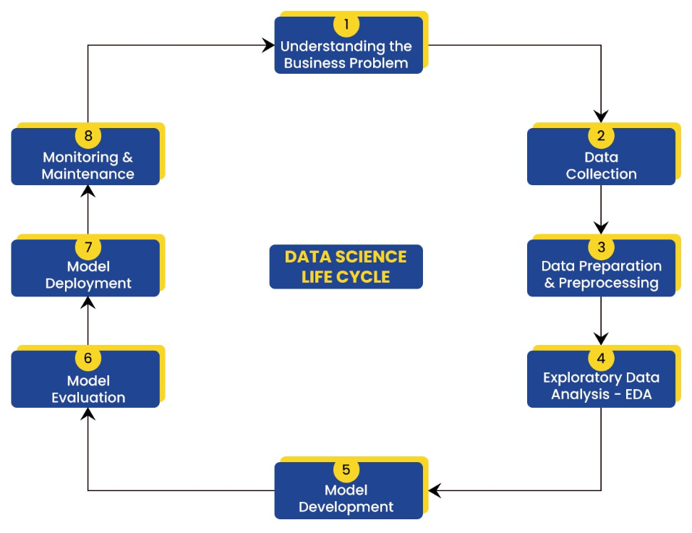

Step III: Data Preparation & Preprocessing
You have got your data. Great! But it’s probably not ready to use yet. Real-world data is often messy, incomplete, or in the wrong format.
Think of this step as getting data ready before EDA:
- finding and fixing errors
- transforming data into the right format
- standardizing and scaling
- dealing with outliers or bad data
This step needs patience, attention to detail, and domain knowledge. The cleaner your data, the more reliable your analysis and models will be.
Step IV: Exploratory Data Analysis – EDA
Exploratory Data Analysis (EDA) is one of the most crucial steps in any data science project. It involves inspecting, cleaning, transforming, and visualizing data to extract meaningful insights, which will, in turn, guide your data modeling and machine learning workflows.
- Data Summarization: Understanding the main features of your dataset.
- Visualization: Plotting and visualizing trends, patterns, and outliers.
- Correlation Analysis: Identifying relationships between variables.
- Handling Missing Data: Techniques for managing incomplete datasets.
- Outlier Detection: Recognizing anomalies in the data.
- Insights for Model Building: Using EDA to inform decisions on feature selection, transformations, and model selection.
Step V: Model Development
This is where the “science” in data science often shines. All the insight you have explored is used as a foundation to build a model. A model is a mathematical representation that learns patterns from your data.
What does building a model involve?
- Choosing an Algorithm: There are many machine learning algorithms available. Each suits different problems and data types. Your choice depends on your project goal (from step I) and what you learned about your data (from Step IV).
- Splitting Your Data: This is critical for honest evaluation. Don’t use all your data to train the model. Instead, divide it.
- Training the Model: The algorithm processes the training data and learns patterns. It adjusts its internal settings to minimize errors .

Step VII: Model Deployment
Now, the next step in data science life cycle is model deployment. Testing shows it works well and meets project goals. Fantastic! But a model sitting on your computer isn’t creating value. The deployment step is about putting your model into production.
Step VIII: Monitoring & Maintenance
A model that worked great at first might get worse over time. This is why the final step in data science life cycle is monitoring and maintenance. And it never really ends
Q.3. Difference between structureed and unstructured data?
Aspect | Structured Data | Unstructured Data
Schema | Fixed, predefined | No fixed schema
Format | Rows and columns (tabular) | Free-form (text, image, audio, video)
Storage | Relational databases, spreadsheets | Data lakes, NoSQL, file systems
Analysis | Easy — SQL, simple stats | Hard — needs ML/NLP
Examples | Gradebooks, bank transactions | Emails, PDFs, images, social posts
Volume | Smaller share (~20%) | Majority (~80-90%) of data today

Q.4. List five real world application of data science.
Five Real-World Applications of Data Science
- Recommendation systems (Netflix, Amazon)
- Fraud detection in banking
- Healthcare diagnosis and predictive treatment
- Self-driving cars (using sensor data)
- Social media sentiment analysis

